Tutorial on How to Hack S60v3 SymbianOS 9.1 Devices

REQUIREMENTS:
1. Install SignSis v1.03.Repacked.sisx attached to this post on your phone.
2. Install X-plore if you don't already have it installed.
3. Press 0 in X-plore to bring up the settings dialog & ensure that Show Hidden files & Show system files/folders are enabled/checked.
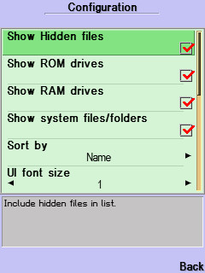

Also ensure that in Application Manager, Press Options, Select Settings -> Software Installation is set to All and Online certif. check is set to Off
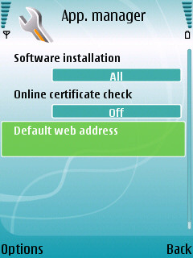

STEP 1: LET'S HACK YOUR PHONE FIRST
Unrar ROMPatcher pre-FP1.rar & install s60_3_0_app_trk_2_7.sisx to Phone Memory

What is ROMPatcher?
ROMPatcher is an amazing piece of code, application allowing you to patch the ROM in a very easy and secure way. We are only limited by our imagination when it comes to the number of uses for it. There is no real danger in using it because it maps the ROM into RAM and then modifies it, so the patch is not permanent and a phone restart will clean all changes made by the patcher. After restart, you have to manually enable the patches again.

Make sure Nokia PC Suite is not running. Now connect your phone to PC using the USB cable in PC Suite mode.
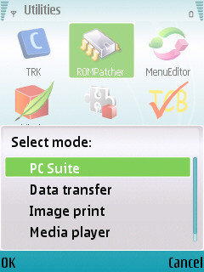

By default TRK starts in Bluetooth mode, Cancel it. Then go to Options ->Settings and change it to USB. And select Connect. When done TRK will show connected.

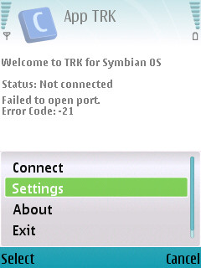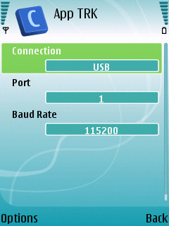

You should see something like this:
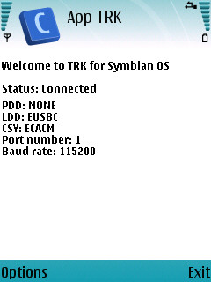

Now find out the port number of your phone USB connection from the device manager. (Tip: Start Menu -> Run -> devmgmt.msc). In the following image it is COM4 for my N73.
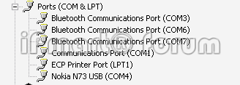

On the PC now run RPInstaller.exe from ROMPatcher pre-FP1.rar and enter the COM port number. Now click on Install Button (do not tick the box). If successful, you will see something like this:
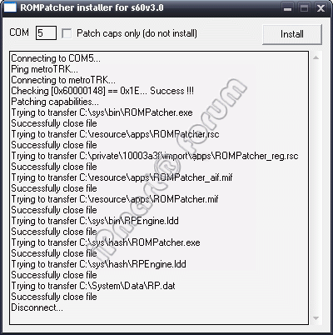

If no errors occured, you will find a new application ROMPatcher in your phone's Applications folder (Do not start it yet). Now close the RPinstaller application on your PC. Exit from the TRK on your phone and then disconnect the cable and reboot your phone.


Open ROMPatcher in phone and select Disable caps from Options menu to enable you to activate the hack. Then Exit the application. That’s it. Your phone has been hacked! To deactivate, select Enable caps from Options menu. It’s that easy!

